**Support Vector Machine (SVM)**

Mathematical intuition:- <https://www.analyticsvidhya.com/blog/2021/10/support-vector-machinessvm-a-complete-guide-for-beginners/>

**What are SVMs?**

A support vector machine (SVM) is a [supervised machine learning](https://www.ibm.com/topics/supervised-learning) algorithm that classifies data by finding an optimal line or hyperplane that maximizes the distance between each class in an N-dimensional space.

SVMs were developed in the 1990s by Vladimir N. Vapnik and his colleagues, and they published this work in a paper titled "Support Vector Method for Function Approximation, Regression Estimation, and Signal Processing"1 in 1995.

SVMs are commonly used within classification problems. They distinguish between two classes by finding the optimal hyperplane that maximizes the margin between the closest data points of opposite classes. The number of features in the input data determine if the hyperplane is a line in a 2-D space or a plane in a n-dimensional space. Since multiple hyperplanes can be found to differentiate classes, maximizing the margin between points enables the algorithm to find the best decision boundary between classes. This, in turn, enables it to generalize well to new data and make accurate classification predictions. The lines that are adjacent to the optimal hyperplane are known as support vectors as these vectors run through the data points that determine the maximal margin.

The SVM algorithm is widely used in [machine learning](https://www.ibm.com/think/topics/machine-learning) as it can handle both linear and nonlinear classification tasks. However, when the data is not linearly separable, kernel functions are used to transform the data higher-dimensional space to enable linear separation. This application of kernel functions can be known as the “kernel trick”, and the choice of kernel function, such as linear kernels, polynomial kernels, radial basis function (RBF) kernels, or sigmoid kernels, depends on data characteristics and the specific use case.

A Support Vector Machine (SVM) is a [**machine learning algorithm**](https://www.analyticsvidhya.com/blog/2022/01/machine-learning-algorithms/) used for classification and regression. This finds the best line (or hyperplane) to separate data into groups, maximizing the distance between the closest points (support vectors) of each group. It can handle complex data using kernels to transform it into higher dimensions. In short, SVM helps classify data effectively.

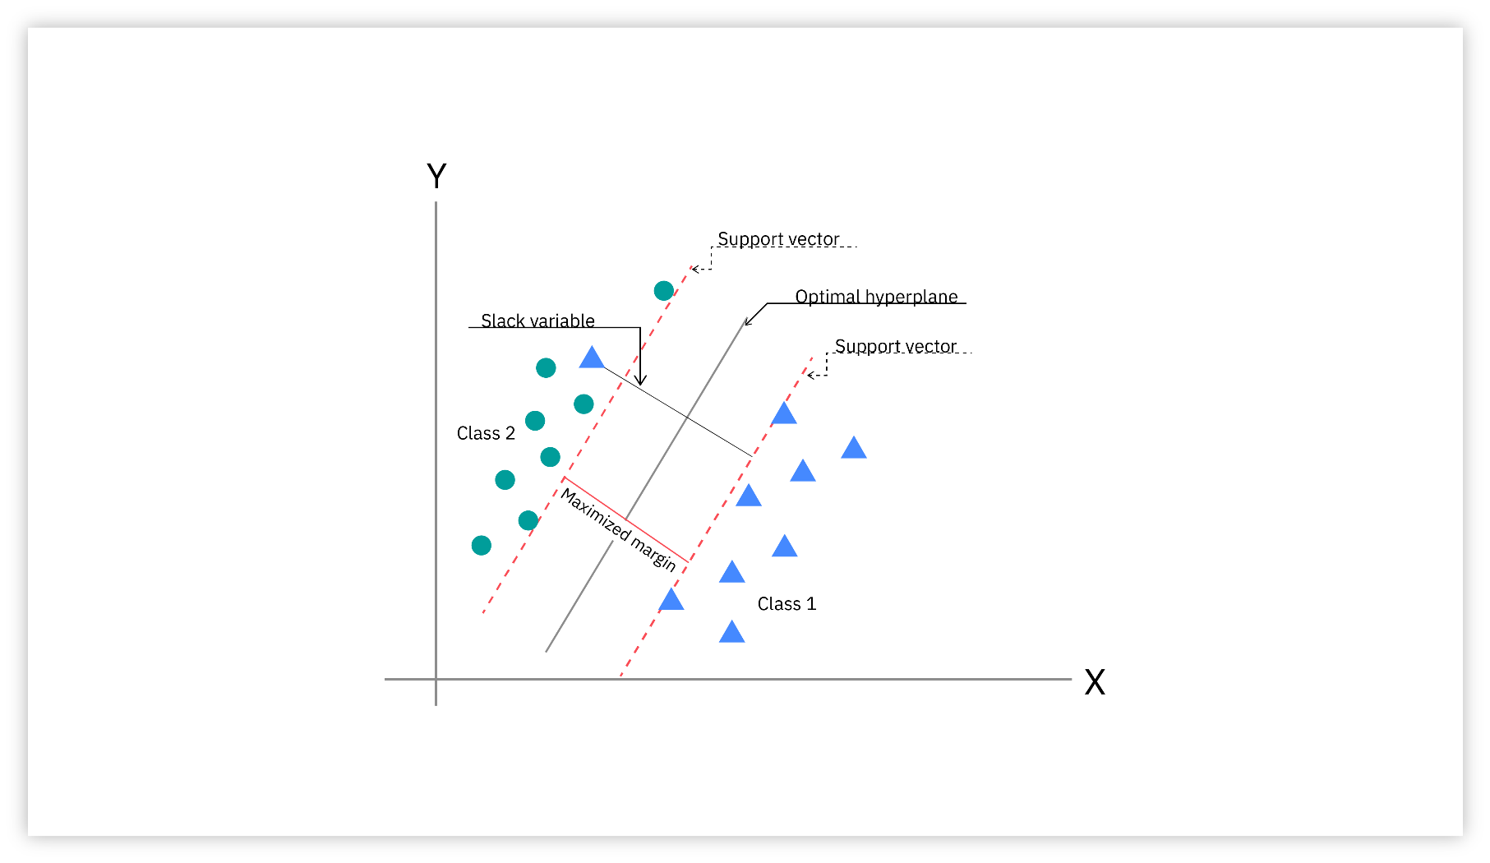

-----------------------------------------------------------------------------------------------------------------------------------------

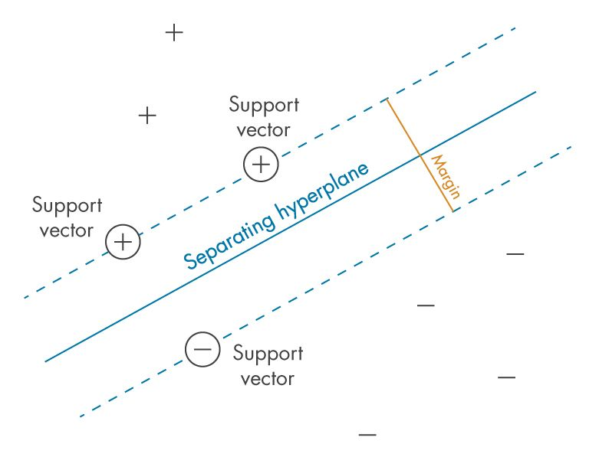

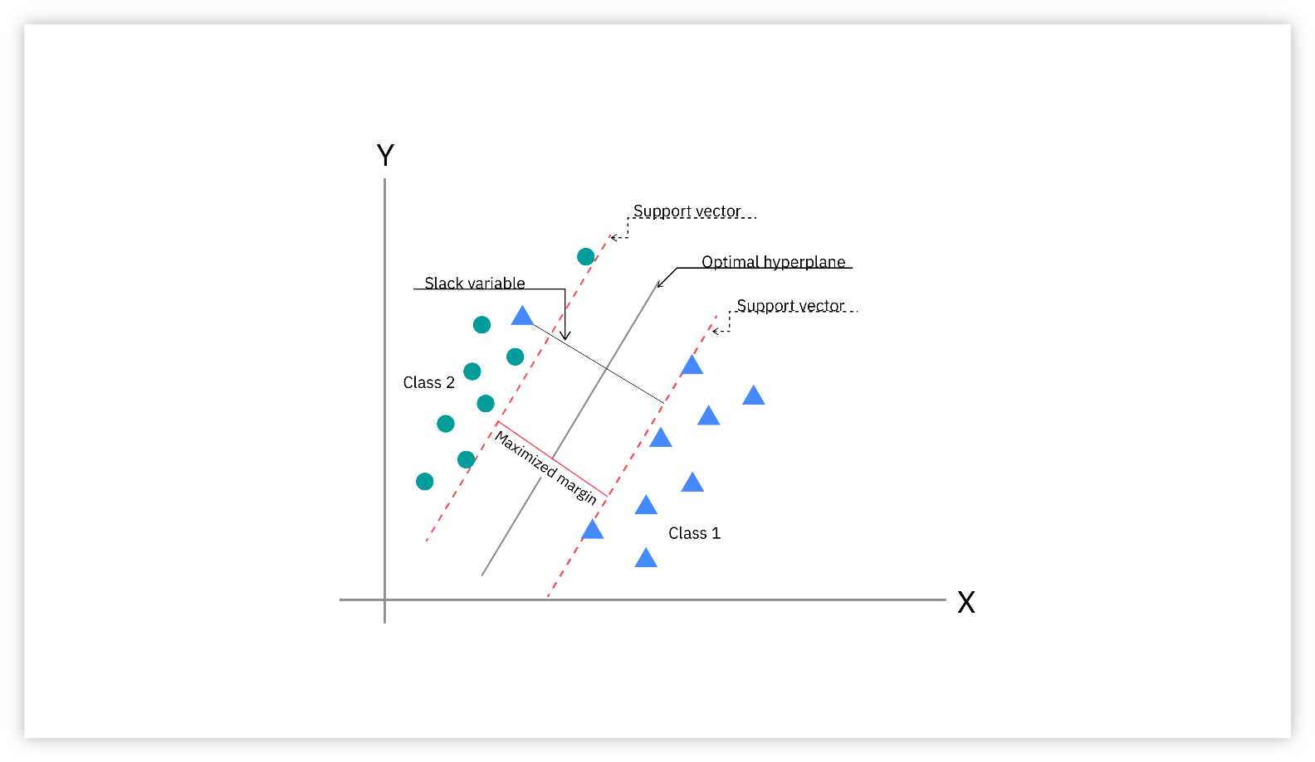

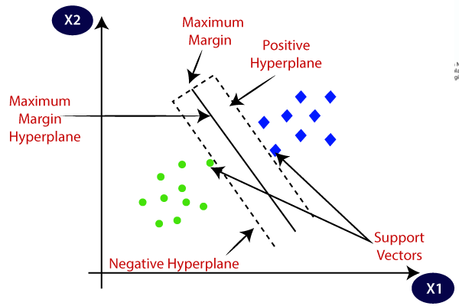

**Types of SVM classifiers**

**Linear SVMs**

Linear SVMs are used with linearly separable data; this means that the data do not need to undergo any transformations to separate the data into different classes. The decision boundary and support vectors form the appearance of a street, and Professor Patrick Winston from MIT uses the analogy of "[fitting the widest possible street](https://ocw.mit.edu/courses/6-034-artificial-intelligence-fall-2010/resources/mit6_034f10_svm/)"2 (link resides outside ibm.com) to describe this quadratic optimization problem. Mathematically, this separating hyperplane can be represented as:

*wx + b = 0*

where *w* is the weight vector, *x* is the input vector, and *b* is the bias term.

There are two approaches to calculating the margin, or the maximum distance between classes, which are hard-margin classification and soft-margin classification. If we use a hard-margin SVMs, the data points will be perfectly separated outside of the support vectors, or "off the street" to continue with Professor Hinton’s analogy. This is represented with the formula,

(wxj + b) yj ≥ a,

and then the margin is maximized, which is represented as: max ɣ= a / ||w||, where a is the margin projected onto *w*.

Soft-margin classification is more flexible, allowing for some misclassification through the use of slack variables (`ξ`). The hyperparameter, C, adjusts the margin; a larger C value narrows the margin for minimal misclassification while a smaller C value widens it, allowing for more misclassified data3.

**Nonlinear SVMs**

Much of the data in real-world scenarios are not linearly separable, and that’s where nonlinear SVMs come into play. In order to make the data linearly separable, preprocessing methods are applied to the training data to transform it into a higher-dimensional feature space. That said, higher dimensional spaces can create more complexity by increasing the risk of overfitting the data and by becoming computationally taxing. The “kernel trick” helps to reduce some of that complexity, making the computation more efficient, and it does this by replacing dot product calculations with an equivalent kernel function4.

There are a number of different kernel types that can be applied to classify data. Some popular kernel functions include:

* Polynomial kernel
* Radial basis function kernel (also known as a Gaussian or RBF kernel)
* Sigmoid kernel

**Support vector regression (SVR)**

Support vector regression (SVR) is an extension of SVMs, which is applied to regression problems (i.e. the outcome is continuous). Similar to linear SVMs, SVR finds a hyperplane with the maximum margin between data points, and it is typically used for time series prediction.

SVR differs from [linear regression](https://www.ibm.com/topics/linear-regression) in that you need to specify the relationship that you’re looking to understand between the independent and dependent variables. An understanding of the relationships between variables and their directions is valuable when using linear regression. This is unnecessary for SVRs as they determine these relationships on their own.

**Important Points**

1. **Maximizes the Margin**:  
   SVM focuses on finding the decision boundary that maximizes the margin (the distance between the boundary and the closest data points of each class). This makes it more robust to new data.
2. **Handles Non-Linear Data**:  
   SVM can handle non-linear data using the “kernel trick,” which transforms the data into a higher-dimensional space where it becomes easier to separate.
3. **Effective in High Dimensions**:  
   SVM works well even when the number of features (dimensions) is much larger than the number of samples, making it suitable for complex datasets.
4. **Robust to Overfitting**:  
   By focusing on the points closest to the boundary (support vectors), SVM is less likely to overfit, especially in smaller datasets.
5. **Requires Tuning**:  
   SVM requires careful tuning of parameters (like the choice of kernel and regularization) to achieve optimal performance, which can be time-consuming.

**Advantages of Support Vector Machine**

1. **Works well with complex data:** SVM is great for datasets where the separation between categories is not clear. It can handle both linear and non-linear data effectively.
2. **Effective in high-dimensional spaces:** SVM performs well even when there are more features (dimensions) than samples, making it useful for tasks like text classification or image recognition.
3. **Avoids overfitting:** SVM focuses on finding the best decision boundary (margin) between classes, which helps in reducing the risk of overfitting, especially in high-dimensional data.
4. **Versatile with kernels:** By using different kernel functions (like linear, polynomial, or radial basis function), SVM can adapt to various types of data and solve complex problems.
5. **Robust to outliers:** SVM is less affected by outliers because it focuses on the support vectors (data points closest to the margin), which helps in creating a more generalized model.

Disadvantages of Support Vector Machine

1. **Slow with large datasets:** SVM can be computationally expensive and slow to train, especially when the dataset is very large.
2. **Difficult to tune:** Choosing the right kernel and parameters (like C and gamma) can be tricky and often requires a lot of trial and error.
3. **Not suitable for noisy data:** If the dataset has too many overlapping classes or noise, SVM may struggle to perform well because it tries to find a perfect separation.
4. **Hard to interpret:** Unlike some other algorithms, SVM models are not easy to interpret or explain, especially when using non-linear kernels.
5. **Memory-intensive:** SVM requires storing the support vectors, which can take up a lot of memory, making it less efficient for very large datasets.

**How Does Support Vector Machine Algorithm Work?**

SVM is defined such that it is defined in terms of the support vectors only, we don’t have to worry about other observations since the margin is made using the points which are closest to the hyperplane (support vectors), whereas in logistic regression the classifier is defined over all the points. Hence SVM enjoys some natural speed-ups.

Let’s understand the working of SVM using an example. Suppose we have a dataset that has two classes (green and blue). We want to classify that the new data point as either blue or green.

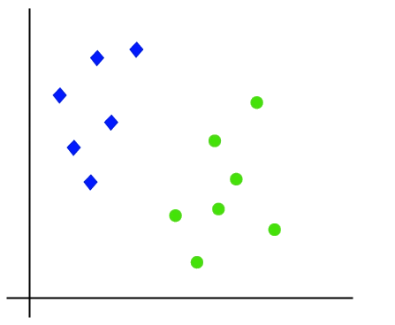

To classify these points, we can have many decision boundaries, but the question is which is the best and how do we find it?

***NOTE:****Since we are plotting the data points in a 2-dimensional graph we call this decision boundary a****straight line****but if we have more dimensions, we call this decision boundary a****“hyperplane”***

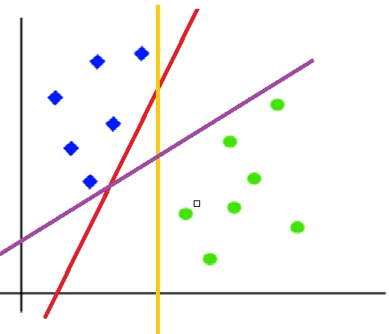

The best hyperplane is that plane that has the maximum distance from both the classes, and this is the main aim of SVM. This is done by finding different hyperplanes which classify the labels in the best way then it will choose the one which is farthest from the data points or the one which has a maximum margin.

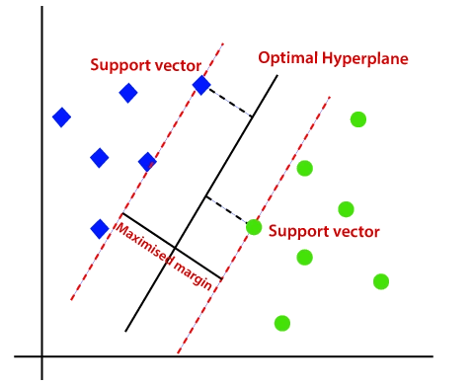

Advantages of Support Vector Machine

**SVMs vs. other supervised learning classifiers**

Different machine learning classifiers can be used for the same use case. It's important to test out and evaluate different models to understand which ones perform the best. That said, it can be helpful to understand the strengths and weaknesses of each to assess its application for your use case.

**SVMs vs naive bayes**

Both Naive Bayes and SVM classifies are commonly used for text classification tasks. SVMs tend to perform better than Naive Bayes when the data is not linearly separable. That said, SVMs have to tune for different hyperparameters and can be more computationally expensive.

**SVMs vs logistic regression**

SVMs typically perform better with high-dimensional and unstructured datasets, such as image and text data, compared to logistic regression. SVMs are also less sensitive to overfitting and easier to interpret. That said, they can be more computationally expensive.

**SVMs vs decision trees**

SVMs perform better with high-dimensional data and are less prone to overfitting compared to decision trees. That said, decision trees are typically faster to train, particularly with smaller datasets, and they are generally easier to interpret.

**SVM vs. neural networks**

Similar to other model comparisons, SVMs are more computationally expensive to train and less prone to overfitting, but neural networks are considered more flexible and scalable.

**Logistic Regression VS Support Vector Machine (SVM)**

Logistic Regression

1. **Probabilistic Approach**:  
   Logistic Regression predicts the probability that an input belongs to a specific class (e.g., 80% chance of being “spam”). It uses the sigmoid function to map inputs to probabilities between 0 and 1.
2. **Linear Decision Boundary**:  
   It assumes the data can be separated by a straight line (or a hyperplane in higher dimensions). If the data isn’t linearly separable, Logistic Regression may struggle.
3. **Simple and Interpretable**:  
   It’s easy to implement and interpret, making it a good starting point for classification problems. The coefficients of the model can also tell you how each feature influences the outcome.
4. **Works Well for Linearly Separable Data**:  
   Logistic Regression performs well when the relationship between the input features and the output is linear.
5. **Efficient for Large Datasets**:  
   It’s computationally efficient and scales well to large datasets, making it a popular choice for many real-world applications.

**Applications of SVMs**

While SVMs can be applied for a number of tasks, these are some of the most popular applications of SVMs across industries.

**Text classification**

SVMs are commonly used in natural language processing (NLP) for tasks such as sentiment analysis, spam detection, and topic modeling. They lend themselves to these data as they perform well with high-dimensional data.

**Image classification**

SVMs are applied in image classification tasks such as object detection and image retrieval. It can also be useful in security domains, classifying an image as one that has been tampered with.

**Bioinformatics**

SVMs are also used for protein classification, gene expression analysis, and disease diagnosis. SVMs are often applied in [cancer research](https://pmc.ncbi.nlm.nih.gov/articles/PMC5822181/#R4) (link resides outside ibm.com) because they can detect subtle trends in complex datasets.

**Geographic information system (GIS)**

SVMs can analyze layered geophysical structures underground, filtering out the 'noise' from electromagnetic data. They have also helped to predict the seismic liquefaction potential of soil, which is relevant to field of civil engineering.

**Hyperparameter tuning**

**Intuition behind SVM:**

**deep intuition behind Support Vector Machines (SVMs)** step-by-step — not just the math, but the reasoning and what it really means. You’ll walk away with both theoretical clarity and a visual/mental model of how SVM thinks.

**🧠 What is the Core Idea of SVM?**

SVM is a **supervised learning algorithm** used for **classification** and sometimes **regression**.

🔥 **Core Idea**:  
**Find the best boundary (hyperplane) that separates two classes with the maximum margin.**

This hyperplane is not just any boundary — it’s the one that **stays as far away as possible from both classes**. This is **why SVM generalizes well**.

**🚧 Problem Setup**

Let’s assume:

* You have two classes: 🟥 Red ("Yes") and 🟦 Blue ("No")
* Each data point has **two features** so it can be plotted in 2D space

**Visual Goal**

You want to draw a **line** (or more generally, a hyperplane) that divides the red and blue points.

But unlike other classifiers (like logistic regression), **SVM doesn’t just care about correct separation**. It wants **maximum separation** — that’s called the **margin**.

**🎯 Step-by-Step Intuition**

**1. Separating the Classes**

First, SVM checks:  
Can I draw a straight line that separates the classes perfectly?

If yes → It becomes a **hard-margin SVM**  
If not → Use **soft-margin SVM** with slack (explained later)

But let’s stay with the simpler case for now — perfectly separable data.

**2. What is a Margin?**

A **margin** is the distance between the separating hyperplane and the **closest data point from either class**.

SVM wants to **maximize this margin** to make the classifier **robust**. Why?

Because if new data is slightly noisy, a bigger margin makes misclassification less likely.

**3. Who Decides the Margin?**

This is where **Support Vectors** come in.

**Support vectors** are the few points **closest** to the decision boundary.  
They are the **most “at risk” of misclassification**, so they are **critical to the model**.

Only these points matter in training; **all other points are ignored** once the margin is set.

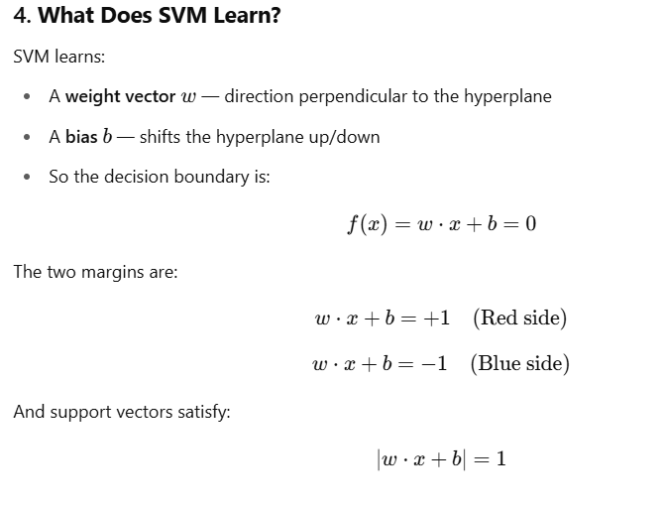

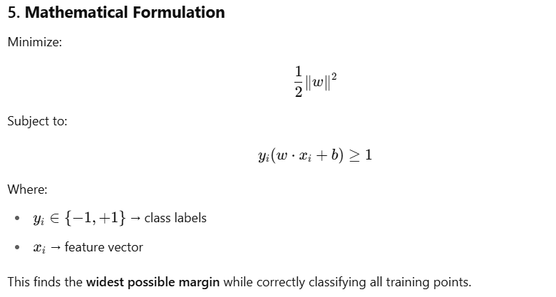

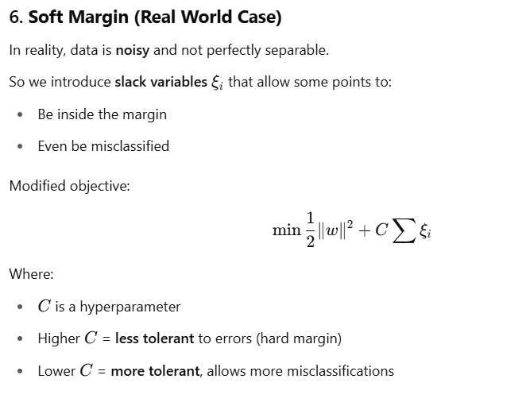

**7. What About Nonlinear Data?**

Sometimes the data can’t be separated with a straight line.

Example: Red dots in the middle, blue in a ring around it.

In that case, SVM uses a **kernel function** to project data into a **higher-dimensional space**, where it **can be separated linearly**.

Popular kernels:

| **Kernel** | **What It Does** |
| --- | --- |
| Linear | No transformation, just a line |
| Polynomial | Adds polynomial features |
| RBF (Gaussian) | Maps data to infinite-dimensional space |
| Sigmoid | Similar to neural networks |

**8. Geometric Intuition Recap**

SVM tries to:

* Place a line (or hyperplane) between two classes
* Maximize the distance from the line to the nearest point in each class
* Use **only** the points that touch the margin: the **support vector**

**✅ Summary Table**

| **Concept** | **Meaning** |
| --- | --- |
| **Support Vectors** | Closest points from each class to the hyperplane |
| **Hyperplane** | Decision boundary between classes |
| **Margin** | Distance from hyperplane to support vectors |
| **Slack variables** | Allow soft-margin (some errors) |
| **Kernel** | Maps data to higher dimensions for separation |
| **Optimization Goal** | Maximize margin by minimizing ∥w∥^2 |
| **Robustness** | Larger margin → better generalization |

**Problem Setup**

Let’s say you're working with a binary classification problem:

* **Two classes**: "Yes" (Red points) and "No" (Blue points)
* **Two features**: So we can plot the data in 2D.
* You **plot** your data points, but you haven't yet drawn any decision boundary.

**💡 Objective of SVM**

Find a **line (hyperplane)** that:

* **Separates** the red and blue classes
* **Maximizes the margin** (the distance from the line to the nearest point on **each side**)

**🤔 First Key Confusion: What Comes First?**

❓Do we **find support vectors first**, or do we **find the hyperplane first**?

✅ **Answer**: Neither.  
Both the **hyperplane** and the **support vectors** are found **together**, by solving an **optimization problem**.

Let’s explain what that means.

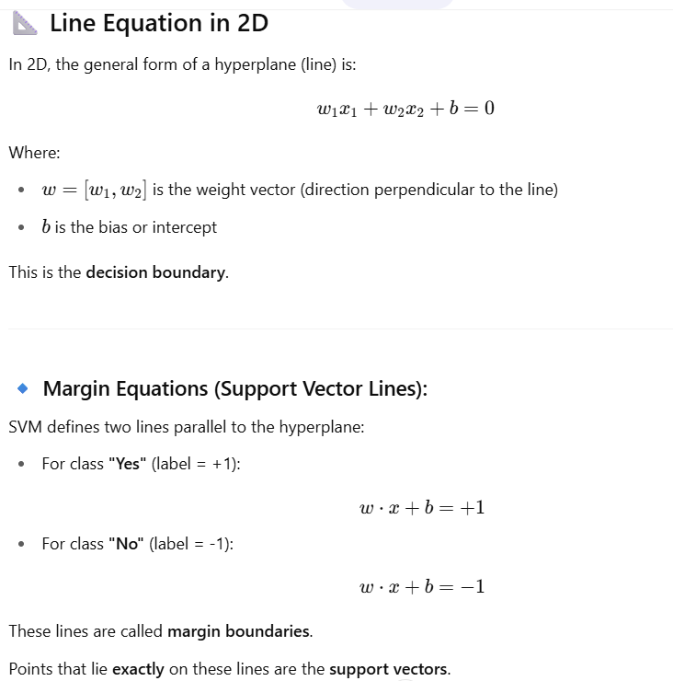

**Now... How Does SVM Actually Find the Line?**

**Step-by-Step Intuition:**

1. **Plot all the data**: Red and blue points (no hyperplane yet).
2. Now we want to **find the best line that separates them**.

But not **just any line** — we want the line that:

* Separates the two classes correctly
* Has the **maximum possible distance** (margin) to the closest red and closest blue points

This is formulated as a **convex optimization problem**:

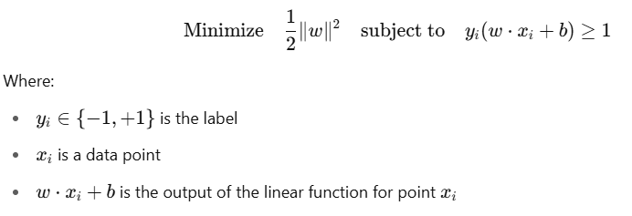

**Key Insight: Support Vectors Are Found During Optimization**

You are **not required to know the support vectors before** choosing the hyperplane.

Instead:

* You try to find a line that keeps all red points on one side and all blue on the other.
* While optimizing the margin, the algorithm **automatically identifies** the few closest points — these become the **support vectors**.



**But… How does SVM know where the two classes are?**

Great point.

Here’s how:

* You provide all the labeled data (i.e., "this point is Red", "that point is Blue").
* The optimization process **knows** which class each point belongs to (via yiy_iyi​).
* It tries to find a hyperplane such that **red points satisfy** w⋅x+b≥+1 and **blue points satisfy** w⋅x+b≤−1
* The algorithm checks **both classes together** and finds the narrowest band (maximum margin) that separates them.

**Understanding the Optimization in SVM**

Once you give the SVM algorithm your data points — **with class labels** (red = +1, blue = -1) — it tries to solve the following problem:

**🎯 Objective:**

Find the line (hyperplane) that **separates the classes** while **maximizing the margin**.

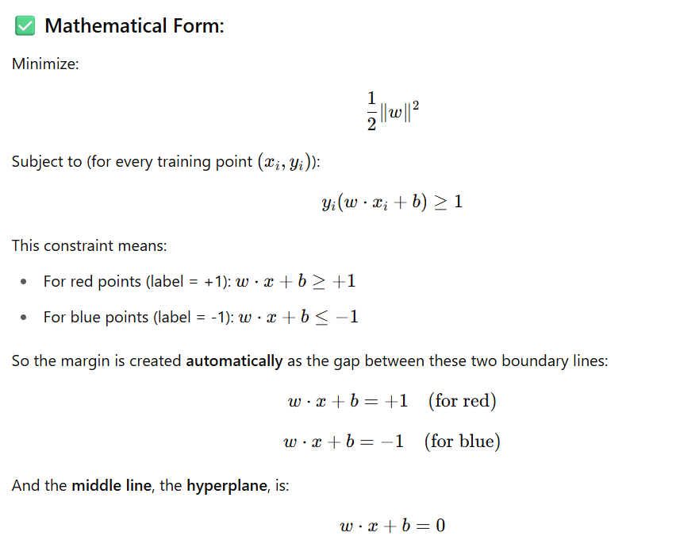

**How Support Vectors Are Determined**

While solving this optimization, the algorithm **only looks at the points that are closest to the hyperplane** — i.e., **the points that lie exactly on**:

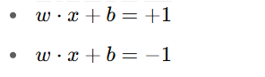

These closest points from **each class** are the **support vectors**. All other points **don’t affect** the placement of the hyperplane.

So:

* ✅ The SVM **does not need to know support vectors beforehand**.
* ✅ It **discovers them while solving** the optimization problem.
* ✅ Once found, the **hyperplane is placed exactly halfway between** the support vectors of both classes.

**Visual Intuition**

Let’s imagine a simple 2D plane.

Red points: top-right

Blue points: bottom-left

Red support vector: (2, 6)

Blue support vector: (4, 2)

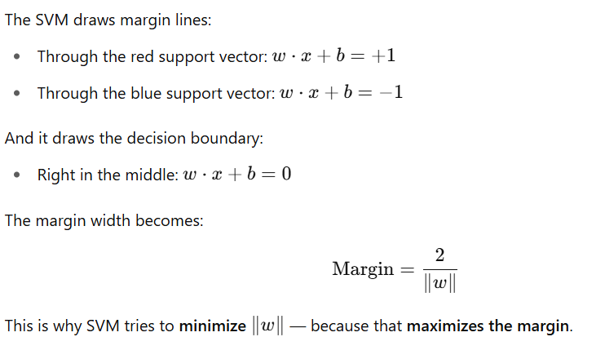

**Summary in Simple Words**

| **Term** | **Meaning** |
| --- | --- |
| **Support Vector** | Points that are closest to the decision boundary — one from each class — and define the margin |
| **Hyperplane** | Line (or plane) that separates the classes with the **maximum margin** |
| **How it's drawn** | Not guessed or preset — it's calculated by solving an optimization problem that maximizes the margin |
| **Line Equations** | Margin: w⋅x+b=±1 Hyperplane: w⋅x+b=0 |

**✅ You Asked: "What if I don’t know where the blue class lies?"**

* When you **only plot the red points**, you cannot decide the hyperplane yet — **you need both classes** to compute the margin.
* Only after giving all data with class labels can SVM find:
  + Which red point is closest to the blue group
  + Which blue point is closest to the red group
  + Then, it places the decision boundary in between them

That’s why it’s **not about drawing the line first** — it’s about solving a mathematical problem to discover **both** the support vectors **and** the line **together**.

**Constraints Optimization Problem in SVM (Soft Margin)**

**Hard Margin and Soft Margin SVM**

**Hard Margin and Soft Margin SVM** with the **red-blue point example**, and understand **how and why they differ — both theoretically and practically.**

**🔵🔴 Imagine a Binary Classification Problem**

You have:

* Red points (Class 0) → 🔴
* Blue points (Class 1) → 🔵
* Each point has 2 features → can be plotted in 2D space

**🎯 Goal of SVM**

**Find the "best separating hyperplane" that maximizes the margin between classes.**

**📌 First, Let’s Understand the "Hard Margin" SVM**

**🔒 Hard Margin SVM (Strict SVM)**

**🔍 Theoretical Conditions:**

* Assumes **data is perfectly linearly separable**.
* No tolerance for misclassification.
* All points must lie **outside** the margin.
* No noise or overlap in the data.

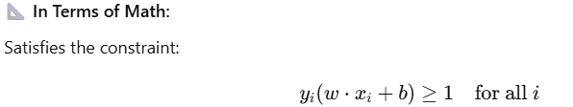

This means:

* Red points lie on one side of the hyperplane.
* Blue points lie on the other side.
* The **margin** is as wide as possible.

**⚠️ When to Use:**

* In rare cases where the dataset is clean, linearly separable, and noise-free.
* Synthetic or idealized datasets.

**❌ Problem:**

* **Real-world data is noisy**.
* Outliers and overlaps cause hard margin SVM to fail (no perfect separator).

**🧵 Now Enter — Soft Margin SVM**

**🎯 Soft Margin SVM (Flexible SVM)**

**🔍 Theoretical Conditions:**

* Allows **some data points** to:
  + Lie **within the margin**
  + Even be **misclassified**

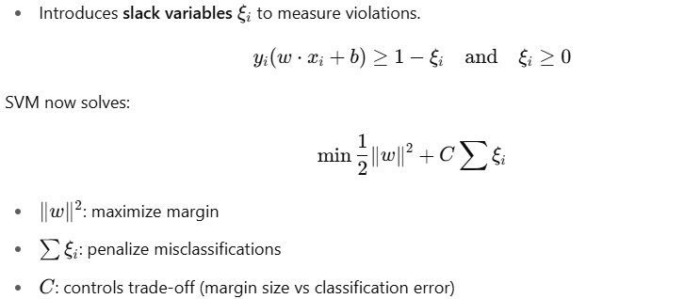

**⚙️ Intuition:**

SVM now **balances** two things:

1. Keep the margin as wide as possible (like hard margin)
2. But also allow some errors to **not overfit**

**📦 When to Use:**

* **Real-world data**
* Noisy or overlapping data
* Outliers are present
* Imperfect class separation

**🔴🔵 Let’s Use the Red-Blue Example**

**✅ In a Hard Margin World:**

If your red 🔴 and blue 🔵 points are nicely clustered apart with no mixing:

* SVM draws a **clear line** between the two.
* All points lie **outside** the margin.
* A wide margin is possible.
* Support vectors touch the margin boundaries exactly.

**❌ But If You Introduce Noise:**

Let’s say a couple of blue 🔵 points end up in the red 🔴 cluster:

* **Hard Margin SVM will fail** — it won’t be able to separate them without misclassifying.
* It may find **no solution**.

**✅ Soft Margin SVM Saves the Day:**

* It allows the few “wrong” blue points to **be within or even on the wrong side** of the boundary.
* It doesn’t let these points dictate the entire decision boundary.
* **The bulk of data still guides the margin**.

**🧠 What Is SVM Optimizing, Conceptually?**

| **Margin Type** | **SVM Is Trying To...** | **Misclassifications?** | **Data Type** |
| --- | --- | --- | --- |
| Hard Margin | Find **widest margin** with 100% accuracy | ❌ Not allowed | Clean, separable |
| Soft Margin | Find **widest *possible* margin**, even with few errors | ✅ Allowed (controlled by C) | Real-world, noisy |

**🔧 C Hyperparameter in Soft Margin SVM**

* **Large CCC** = Try to minimize errors → behaves like hard margin → smaller margin
* **Small CCC** = Allow more slack/errors → wider margin → better generalization

Think of it as:

🧱 **"How hard should SVM try to classify training data perfectly?"**

**✅ Summary**

| **Feature** | **Hard Margin SVM** | **Soft Margin SVM** |
| --- | --- | --- |
| Assumes perfect separation | ✅ Yes | ❌ No |
| Allows margin violations | ❌ No | ✅ Yes (using slack ξ (xi)) |
| Handles noise & outliers | ❌ Poorly | ✅ Robustly |
| Use case | Clean, synthetic data | Noisy, real-world data |
| Controlled by | Margin only | Margin + penalty C |

**Kernal transformation:**

**Why Do We Need Kernel Transformation?**

**🔴🔵 Suppose:**

You’re trying to separate red 🔴 and blue 🔵 data points.

In many real-world cases, **data is not linearly separable** in its original form. That means you **cannot draw a straight line** (or hyperplane) to separate classes perfectly.

**Example:**  
A circular boundary — where red points are surrounded by blue points — a line just won’t work.

So what can we do?

🎯 **We transform the data into a higher-dimensional space where it becomes linearly separable.**

This is the idea behind **Kernel Transformation.**

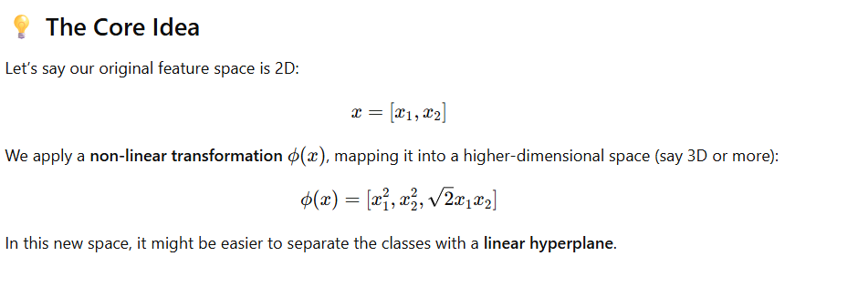

**But Wait — Isn’t That Computationally Expensive?**

Yes! Calculating ϕ(x) for **all training examples** in a very high-dimensional space would be costly.

That’s where the **Kernel Trick** comes in.

**🧙‍♂️ The Kernel Trick**

Instead of explicitly computing ϕ(x) (phi), we compute:

K(x,x′)=ϕ(x)⋅ϕ(x′)

That is, the **dot product of the transformed vectors**, without ever computing the transformation itself.

✅ **Efficient**  
✅ **Implicit high-dimensional mapping**

This function K(x,x′) is called a **kernel function**.

**🧰 Commonly Used Kernels**

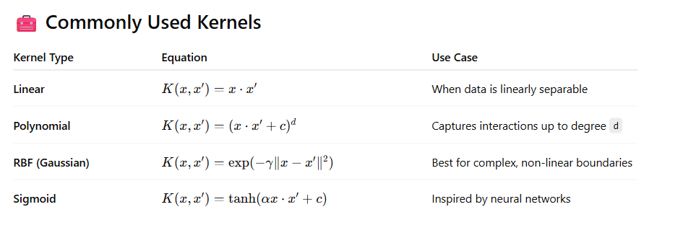

**🧪 Example: RBF Kernel Intuition**

Suppose we have data like this:

* Blue 🔵 points are in the center.
* Red 🔴 points form a ring around them.

This is **not separable by a straight line**, but if we project the data into a **higher-dimensional space** where:



Now, it becomes separable with a **plane in the z-direction**.

RBF kernel does this transformation **implicitly**.

**🧠 Summary of Kernel Transformation**

| **Concept** | **Meaning** |
| --- | --- |
| **Feature Mapping ϕ(x)** | Map low-dimensional data to high-dimensional space |
| **Kernel Trick** | Compute dot product in high-dimensional space without explicit transformation |
| **Kernel Function** | Measures similarity between inputs xxx and x′x'x′ |
| **Why Use** | Enables SVM to solve non-linear problems efficiently |

**1. Linear Kernel**

**📌 Formula:**

K(x,x′)=x⋅x′

**🧠 Intuition:**

* No transformation is applied.
* Equivalent to the standard dot product.
* Works in the **original input space**.

**📈 When to Use:**

* When data is **linearly separable** or almost linear.
* Good for **high-dimensional, sparse data**, e.g.:
  + **Text classification** (bag-of-words, TF-IDF)
  + **Gene expression** data

**⚡ Fast and Simple:**

* Least computational cost
* No extra hyperparameters

**🧮 2. Polynomial Kernel**

**📌 Formula:**

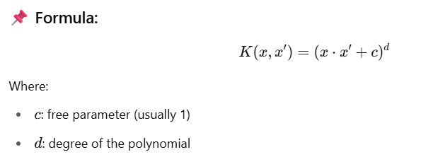

**🧠 Intuition:**

* Captures **interactions** between features.
* Degree d controls the **complexity** of the model.
  + d=2d = 2d=2: includes squares and cross-products
  + d=3d = 3d=3: cubes, triple-feature interactions, etc.

**📈 When to Use:**

* When data is **not linearly separable** but still has **some structured curvature**.
* Useful when you want to **model feature interactions explicitly**.

**⚠️ Drawbacks:**

* Can be computationally expensive with large d
* May overfit with high-degree polynomials

**🌀 3. RBF (Radial Basis Function) / Gaussian Kernel**

**📌 Formula:**

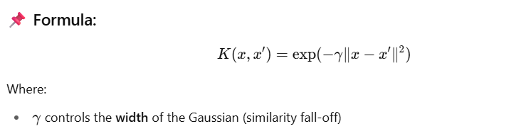

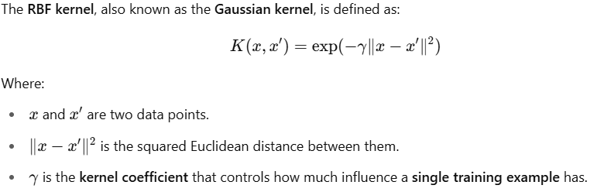

Where:

* γ gamma controls the **width** of the Gaussian (similarity fall-off)

**🎯 What is gamma?**

**✅ It controls the shape and smoothness of the decision boundary.**

* A **small gamma** → **far influence**: each data point affects a large region.
* A **large gamma** → **close influence**: each data point affects only nearby points.

**📌 Intuition**

**🔵 Small gamma (e.g., 0.1 or 0.01):**

* Points are seen as **globally similar**.
* Decision boundary is **smoother** and more **generalized**.
* Risk: **Underfitting** (not flexible enough to capture patterns).

**🔴 Large gamma (e.g., 10 or 100):**

* Points are seen as **only locally similar**.
* Decision boundary is **tightly fitted** to training data.
* Risk: **Overfitting** (fits noise in the training data).

**🧪 Visual Example**

Imagine a data point is a "hill":

* Small gamma → a **wide hill** → affects more area
* Large gamma → a **sharp narrow peak** → affects only nearby space

**📊 Real-world Analogy**

Think of gamma as the **sensitivity knob**:

* Low sensitivity: sees broad differences (low gamma)
* High sensitivity: reacts sharply to small differences (high gamma)

**⚙️ In scikit-learn**

python

CopyEdit

from sklearn.svm import SVC

model = SVC(kernel='rbf', gamma=0.1)

You can also use 'scale' or 'auto':

* 'scale': default, sets gamma = 1 / (n_features * X.var())
* 'auto': sets gamma = 1 / n_features

**🧠 Intuition:**

* Compares distance between points.
* Points **closer** are more similar → higher kernel value.
* Points **farther** are almost zero → ignored.

**📈 When to Use:**

* When the **decision boundary is highly non-linear**.
* Best default choice when:
  + You have **no idea about feature interactions**
  + You suspect **non-linearity** but don’t know the form

**🔧 Hyperparameter:**

* gamma: higher = more sensitive (tight clusters)
* Can **overfit** if gamma too high, or **underfit** if too low

**✅ Often a good first try!**

**🔌 4. Sigmoid Kernel**

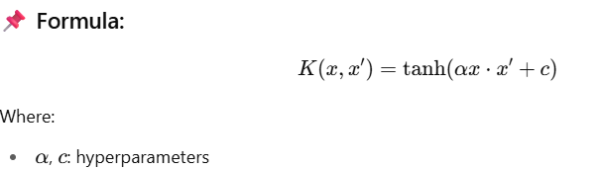

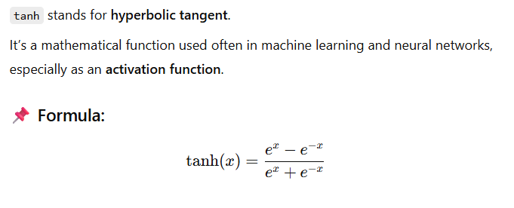

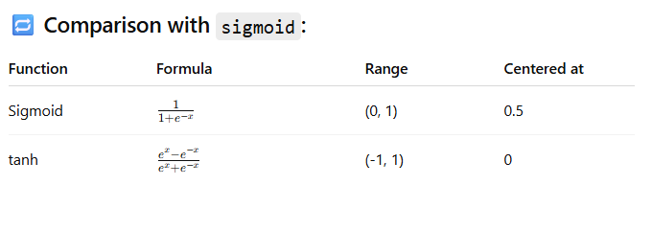

**🧠 Intuition:**

* Inspired by neural networks (activation functions).
* Non-linear transformation of dot product.

**📈 When to Use:**

* Rarely used.
* Historically used when trying to **mimic neural networks** with SVMs.
* May not satisfy Mercer’s condition (validity of kernel matrix) for all values.

**⚠️ Caveats:**

* Often outperformed by RBF in practice.
* Only useful in specific cases, such as **experimentation**.

**🔢 Summary Table**

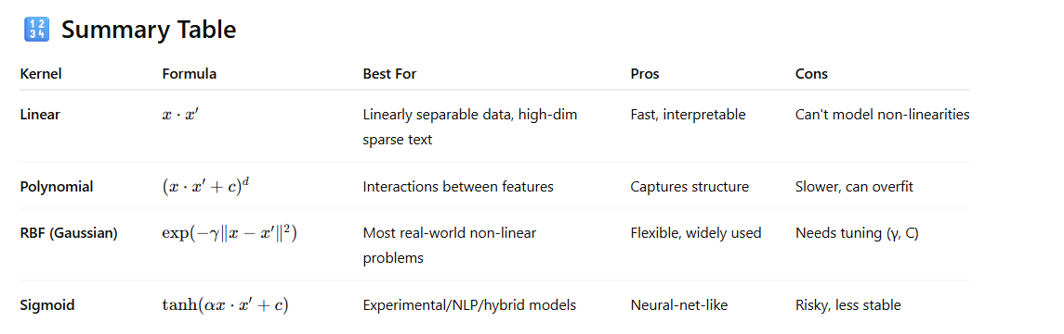

**✅ Choosing the Right Kernel**

| **Scenario** | **Recommended Kernel** |
| --- | --- |
| Clean linear separation | Linear |
| Curved but structured boundary | Polynomial |
| Unknown shape / complex | RBF |
| Mimicking neural nets | Sigmoid (rarely) |

**1. Linear Data — linear kernel**

**🧠 Intuition:**

* Data is **linearly separable** (can be separated by a straight line/hyperplane).
* SVM finds the best linear separator.

**🔢 Code:**

python

CopyEdit

from sklearn import datasets

from sklearn.svm import SVC

from sklearn.model_selection import train_test_split

import matplotlib.pyplot as plt

from mlxtend.plotting import plot_decision_regions

# Load linear data (only 2 features for plotting)

X, y = datasets.make_classification(n_samples=100, n_features=2,

n_redundant=0, n_informative=2,

n_clusters_per_class=1, random_state=1)

# Train SVM with linear kernel

model = SVC(kernel='linear', C=1)

model.fit(X, y)

# Plot decision boundary

plot_decision_regions(X, y, clf=model)

plt.title('SVM with Linear Kernel')

plt.show()

**✅ 2. Nonlinear Data — rbf kernel**

**🧠 Intuition:**

* Data can't be separated by a straight line.
* RBF (Radial Basis Function) kernel maps data into higher-dimensional space.
* SVM finds a linear separator **in that space**, which is **non-linear in original space**.

**🔢 Code:**

python

CopyEdit

from sklearn.datasets import make_circles

# Create nonlinear (circular) data

X, y = make_circles(n_samples=100, factor=0.3, noise=0.1)

# Train SVM with RBF kernel

model = SVC(kernel='rbf', C=1, gamma='auto')

model.fit(X, y)

# Plot decision boundary

plot_decision_regions(X, y, clf=model)

plt.title('SVM with RBF Kernel')

plt.show()

**✅ 3. Polynomial Data — poly kernel**

**🧠 Intuition:**

* Data follows a **polynomial pattern** (e.g., parabolas, curves).
* Polynomial kernel allows fitting such curves by considering **higher-degree feature interactions**.

**🔢 Code:**

python

CopyEdit

from sklearn.datasets import make_moons

# Create semi-linear but curved (moons) data

X, y = make_moons(n_samples=100, noise=0.1)

# Train SVM with Polynomial kernel

model = SVC(kernel='poly', degree=3, C=1)

model.fit(X, y)

# Plot decision boundary

plot_decision_regions(X, y, clf=model)

plt.title('SVM with Polynomial Kernel (degree=3)')

plt.show()

**🎯 Summary Table**

| **Data Type** | **Kernel Used** | **Use When...** |
| --- | --- | --- |
| Linear | 'linear' | Data is linearly separable |
| Nonlinear (e.g., circular) | 'rbf' | Data requires complex, radial boundaries |
| Polynomial (e.g., U-shape) | 'poly' | Data shows curved but structured boundaries |

from sklearn.svm import SVC

import matplotlib.pyplot as plt

from sklearn.datasets import make_classification

# Create toy data

X, y = make_classification(n_samples=100, n_features=2, n_classes=2, n_clusters_per_class=1)

# Train SVM

clf = SVC(kernel='linear')

clf.fit(X, y)

# Plot

plt.scatter(X[:, 0], X[:, 1], c=y)

ax = plt.gca()

xlim = ax.get_xlim()

w = clf.coef_[0]

b = clf.intercept_[0]

x = np.linspace(xlim[0], xlim[1])

y = -(w[0] * x + b) / w[1] # decision boundary

plt.plot(x, y, 'k--')

# Margins

margin = 1 / np.linalg.norm(w)

y_margin_up = y + margin

y_margin_down = y - margin

plt.plot(x, y_margin_up, 'r--')

plt.plot(x, y_margin_down, 'b--')

plt.title("SVM with Margins")

plt.show()

import numpy as np

import matplotlib.pyplot as plt

from sklearn import datasets

from sklearn.svm import SVC

# Generate synthetic data (2D, binary classification)

X, y = datasets.make_blobs(n_samples=100, centers=2, random_state=6, cluster_std=1.5)

# Train a linear SVM classifier

clf = SVC(kernel='linear', C=1.0)

clf.fit(X, y)

# Get the separating hyperplane parameters

w = clf.coef_[0]

b = clf.intercept_[0]

# Create a grid to plot the decision boundary

x_min, x_max = X[:, 0].min() - 1, X[:, 0].max() + 1

y_min, y_max = X[:, 1].min() - 1, X[:, 1].max() + 1

xx = np.linspace(x_min, x_max, 100)

yy = -(w[0] * xx + b) / w[1] # Decision boundary

margin = 1 / np.sqrt(np.sum(clf.coef_ ** 2))

yy_down = yy - np.sqrt(1 + (w[0]/w[1])**2) * margin

yy_up = yy + np.sqrt(1 + (w[0]/w[1])**2) * margin

# Plot

plt.figure(figsize=(10, 6))

plt.scatter(X[:, 0], X[:, 1], c=y, cmap=plt.cm.coolwarm, s=30)

plt.plot(xx, yy, 'k-', label='Decision boundary (w·x + b = 0)')

plt.plot(xx, yy_down, 'k--', label='Margin (w·x + b = -1)')

plt.plot(xx, yy_up, 'k--', label='Margin (w·x + b = +1)')

plt.scatter(clf.support_vectors_[:, 0], clf.support_vectors_[:, 1],

s=150, facecolors='none', edgecolors='k', label='Support Vectors')

plt.legend()

plt.title('SVM Decision Boundary with Margins and Support Vectors')

plt.xlabel('Feature 1')

plt.ylabel('Feature 2')

plt.grid(True)

plt.show()

**Benefits of Using SVM in Different Contexts**

SVM (Support Vector Machine) is a powerful and flexible algorithm. Here are key **benefits** when dealing with different types of data and problems:

**🔹 1. Handling Outliers (Robustness to Noise)**

* **How SVM helps:**
  + SVM is based on **support vectors**, not all data points.
  + Outliers far away from the margin **don’t affect the decision boundary** much (especially with **soft margin** SVM).

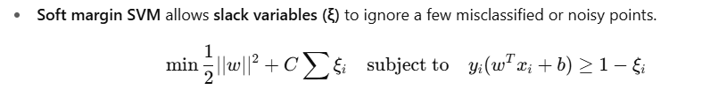

**🔹 2. Non-Linear Data Handling**

* **How SVM helps:**
  + Uses **kernel functions** (like RBF, polynomial) to project data into higher dimensions where it becomes linearly separable.
  + No need to manually add complex features — **kernel trick** handles it efficiently.

**🔹 3. Small and High-Dimensional Datasets**

* **How SVM helps:**
  + Effective in **high-dimensional spaces** (e.g., text classification).
  + Works well when **number of features > number of samples**.

**🔹 4. Clear Margin of Separation**

* SVM explicitly maximizes the **margin** (distance between the hyperplane and nearest points), improving **generalization**.

**🔹 5. Binary Classification**

* SVM excels in binary classification problems with clear class separation.
* For multi-class tasks, one-vs-one or one-vs-rest strategies are used.

**🔹 6. Well-Formulated Optimization Problem**

* SVM uses a **convex optimization problem**:
  + Guarantees a **unique, global minimum**.
  + No local minima issues like neural networks.

**📌 Summary Table**

| **Scenario** | **How SVM Helps** |
| --- | --- |
| Outliers / Noisy Data | Soft margin allows tolerance (controlled by C) |
| Non-linear Data | Kernel trick projects to higher dimension |
| High-dimensional Data | Still performs well; only uses support vectors |
| Small Datasets | Avoids overfitting through margin maximization |
| Clear Class Boundaries | Margin-based optimization finds best separator |
| Optimization Formulation | Convex problem → unique, stable solution |

